Basic Linux Commands Assignment
Name: Muhammad Huzaifa Usman Roll No: 914486 Date: 13-10-2026
Note: Run each command in your own terminal and paste your actual output or screenshot in the Output box.

Task 1: Display current working directory
Commands:
$ pwd
Output (paste your screenshot / text here):
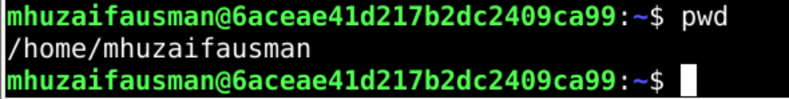

Task 2: Listing files in different ways
Commands:
$ ls
$ ls -a
$ ls -l
$ ls -R
Output (paste your screenshot / text here):
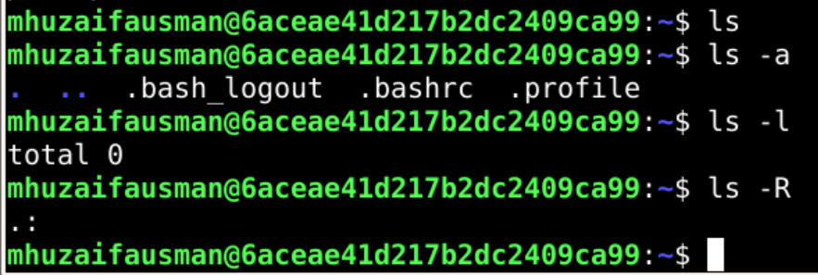

Explanation:
- ls: lists the names of files and directories in the current directory (hidden files are not shown).
- ls -a: lists all entries, including hidden files (names starting with a dot) and the . and .. entries.
- ls -l: long listing format. Shows permissions, number of links, owner, group, size, modification date and name.
- ls -R: recursive listing. Lists the current directory and all of its subdirectories.

Task 3: Create a directory and verify
Commands:
$ mkdir linux_assignment
$ ls
Output (paste your screenshot / text here):
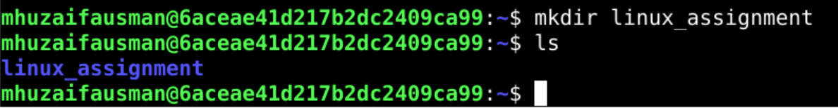

Task 4: Enter the directory and confirm location
Commands:
$ cd linux_assignment
$ pwd
Output (paste your screenshot / text here):

Task 5: Create three empty files
Commands:
$ touch file1.txt file2.txt file3.txt
$ ls -l
Output (paste your screenshot / text here):
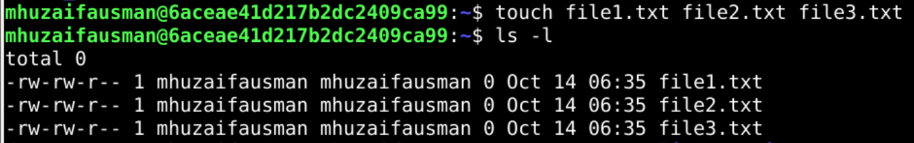

Task 6: Write a message with echo and display it
Commands:
$ echo "Hello, this is my first Linux assignment" > file1.txt
$ cat file1.txt
Output (paste your screenshot / text here):
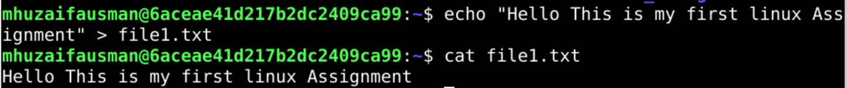

Task 7: Create/edit file2.txt with nano
Commands:
$ nano file2.txt
$ cat file2.txt
Output (paste your screenshot / text here):
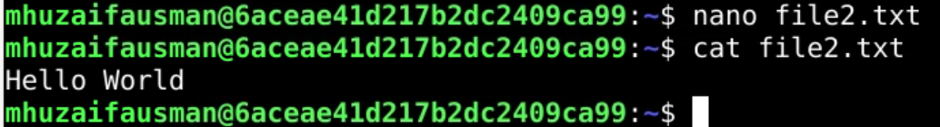

Explanation:
- In nano: type at least three lines, press Ctrl+O then Enter to save, then Ctrl+X to exit.

Task 8: Create backup directory and move file3.txt
Commands:
$ mkdir backup
$ mv file3.txt backup/
$ ls
$ ls backup
Output (paste your screenshot / text here):
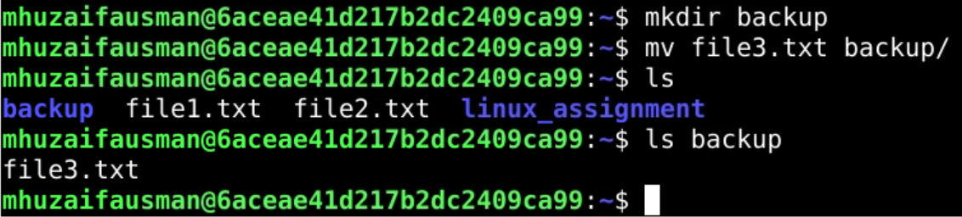

Task 9: Copy file1.txt to file1_copy.txt (only if covered in class)
Commands:
$ cp file1.txt file1_copy.txt
$ ls
Output (paste your screenshot / text here):
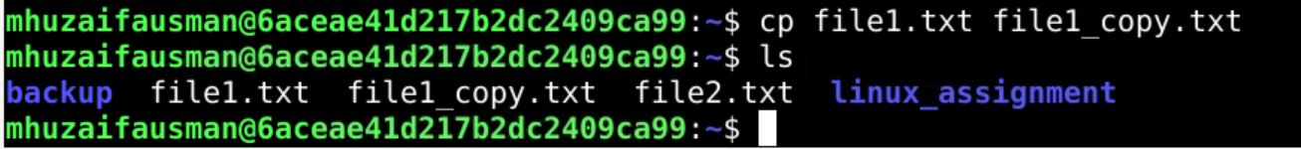

Explanation:
- If cp was not covered in class, write 'Skipped: cp not covered in class' here as the question says.

Task 10: Delete file1_copy.txt
Commands:
$ rm file1_copy.txt
$ ls
Output (paste your screenshot / text here):
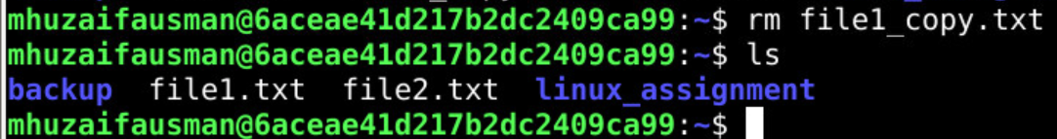

Task 11: Navigating with cd .., cd ~ and cd /
Commands:
$ cd ..
$ pwd
$ cd ~
$ pwd
$ cd /
$ pwd
Output (paste your screenshot / text here):
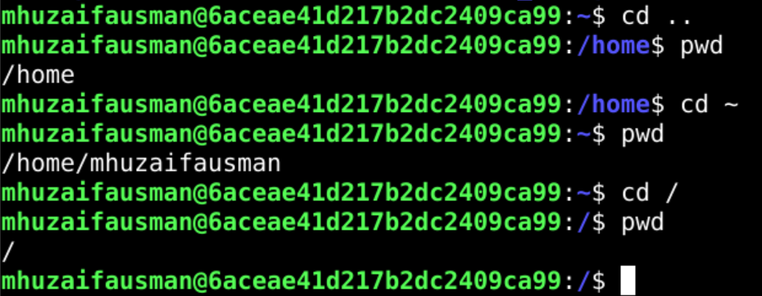

Task 12: Manual for ls and the -a option
Commands:
$ man ls
Output (paste your screenshot / text here):
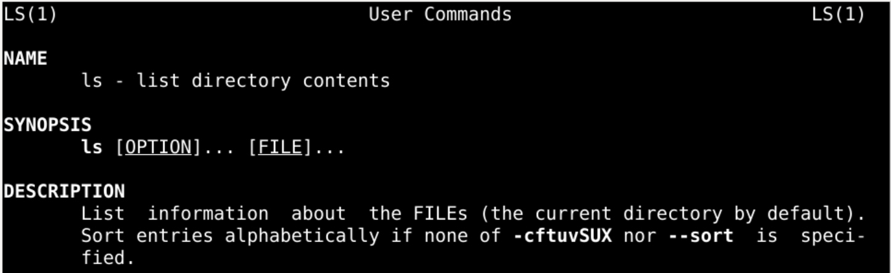

Explanation:
- Inside man, type /-a and press Enter to search; press q to quit.
- Description of -a (as shown in the manual): do not ignore entries starting with '.', i.e. show hidden files.

Task 13: Command history (at least 10 commands)
Commands:
$ history
Output (paste your screenshot / text here):
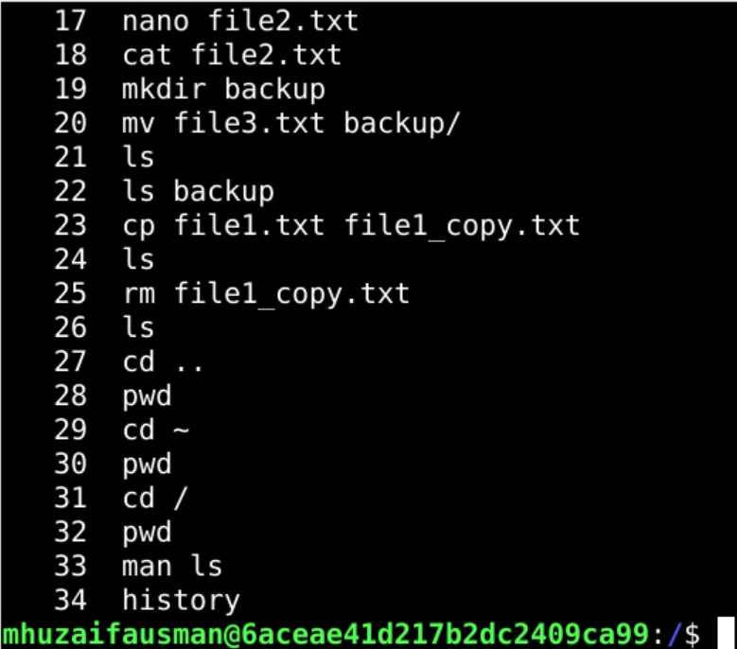

Task 14: which, type and whatis on ls, cd, pwd
Commands:
$ which ls
$ which cd
$ which pwd
$ type ls
$ type cd
$ type pwd
$ whatis ls
$ whatis cd
$ whatis pwd
Output (paste your screenshot / text here):
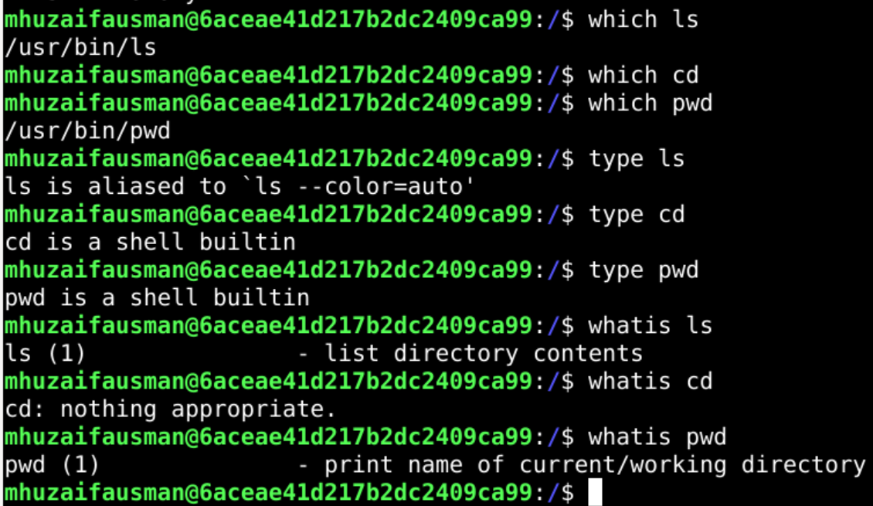

Explanation:
- Fill in after seeing your outputs. Typically: cd is a shell built-in; pwd is a shell built-in (and also exists as /usr/bin/pwd); ls is an external program (/usr/bin/ls, may show as an alias on some systems).
- Note: 'which cd' may print nothing on some systems because cd is a built-in. That is expected.

Task 15: Disk usage
Commands:
$ df -h
$ du -sh ~
Output (paste your screenshot / text here):
